Summary of “Learning to Realize Education’s Promise”
World Development Report 2018, World Bank

The report focuses on three themes (1) the potential for education’s promise, (2) the reality of a global learning crisis, and (3) the need for innovation and effective strategies to improve learning outcomes. It makes clear that education is critical to economic growth and cites the increase in access to education on a global level as a positive development. As access has increased, learning outcomes have failed to provide youth with the foundational skills needed to become part of a competitive workforce. Even with four years of schooling -- up to 125 million children in developing countries are not acquiring functional literacy and numeracy skills. The poorest students are the most affected. Unprepared learners, low teacher skills coupled with lack of motivation, unavailability of relevant inputs, and weak school management and governance – are factors that contribute to a global education crisis. To address these issues, national education systems must assess learning outcomes, act on evidence, and align actors.

Education’s Promise - Effective learning -- the incremental acquisition of skills starting with foundational (reading, writing and math) followed by socio-emotional or non-cognitive skills (interpersonal, control of aggression, focus, conscientiousness, ) and finally technical skills – improves individual freedom, creates the building blocks for inclusive institutions, and promotes economic growth. Increased human capital promotes employment, increases earnings and creates better health outcomes. For society in general, effective education raises pride, drives long-term economic growth, reduces poverty, spurs innovation, strengthens institutions, and fosters social cohesion. Foundational reading, writing and math skills are the start of a process that can create a competitive, innovative workforce. Failure to build a foundation on basic skills puts a country at a critical disadvantage and limits its potential.
“A country’s education level is critical for its economics success. For many years, the economics literature focused on the positive effects of education quantity on growth. However, a growing body of evidence suggests it is not only the quantity of schooling, measured by average years of schooling or enrollment rates, but also the quality of schooling, proxied by student achievement tests, that contributes to growth. It is not about being in school but what is learned in school that matters. Over 15 years of literature now supports this conclusion. The evidence shows that in cross-country regressions when student achievement conditional on years of schooling – rather than years of schooling alone - is correlated with growth, the association and explanatory power of growth models is significantly higher. Research demonstrates a plausibly causal link between cognitive skills and growth.”

Policy Research Working Paper 8314. January 2018. “Global Data Set on Education Quality (1965–2015)” Nadir Altinok, Noam Angrist and Harry Anthony Patrinos.

Learning Crisis – School enrollments have dramatically increased in developing countries with greatest expansion in primary which in turn is creating a higher demand for secondary education. While access is increasing there are factors based on gender and income level of households that limit access. WDR 2018 Team information (pp. 72 – 73) highlights the low level of learning occurring in Africa and Latin America but indicates that these low learning levels are not an inevitable outcome of rapidly expanding access to education. South Korea and Vietnam are mentioned as examples of countries that have increased enrollment and improved learning outcomes. They did so in large part by addressing the needs of the poor and disadvantaged to receive relatively equitable access to quality schooling. Poverty and malnutrition have a significant impact on learning causing poor students to be less prepared and more susceptible to falling behind. Illiteracy at the end of grade 2 has long-term consequences and seriously affects future learning. This is compounded by the finding that there is little to no support to help failing students catch up. The WDR 2018 Team estimates that resulting low skills continue to undermine career opportunities and earnings potential with data, based on 41 countries, indicating more than 2.1 billion of 4.6 billion working age adults (ages 15 – 64) lack crucial foundational skills. The economic impact of this situation is illustrated below with a graph showing the potential economic output that could be realized from increased learning.

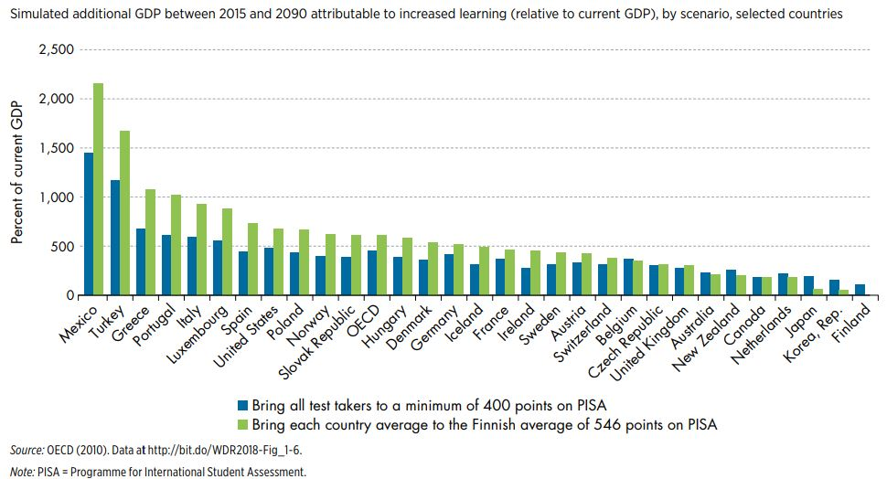

As this above graph of simulations indicates, the potential economic growth that could be achieved by improving cognitive skills is enormous.

The graph on the next page illustrates the impact of national education programs on learning outcomes. It compares number of years of education with actual student learning standardized across different economies using international assessments such as the Trends in International Mathematics and Science Study (TIMSS) or the Programme for International Student Assessment (PISA) to provide a comparison of education effectiveness.

The following graph assumes “… an average learning trajectory across economies is linear—starting at no learning when learners enter school and growing at a constant rate to grade 8—then the ratio of scores across two economies would reflect the relative learning per year in one economy versus the other. Two important facts support the credibility of this analysis: first, the TIMSS score ratios across economies for grade 4 are similar to those for grade 8; and second, PISA scores tend to increase linearly across the grades in which that test is administered.”
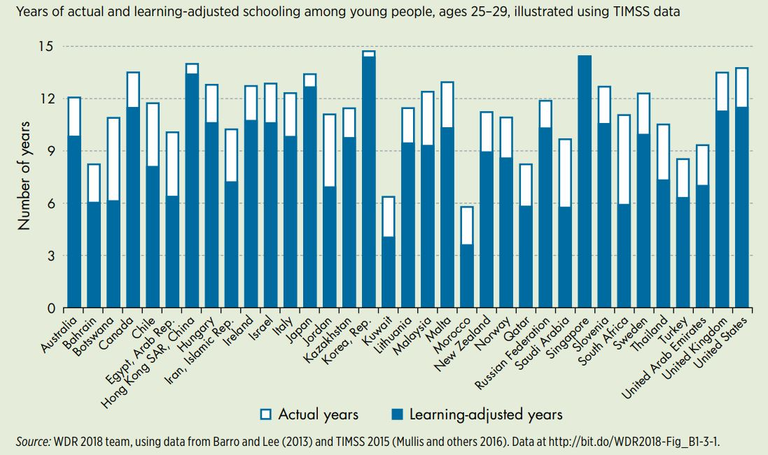

The primary constraints on effective learning are unprepared students, ineffective teachers, lack of school inputs and poor school management:

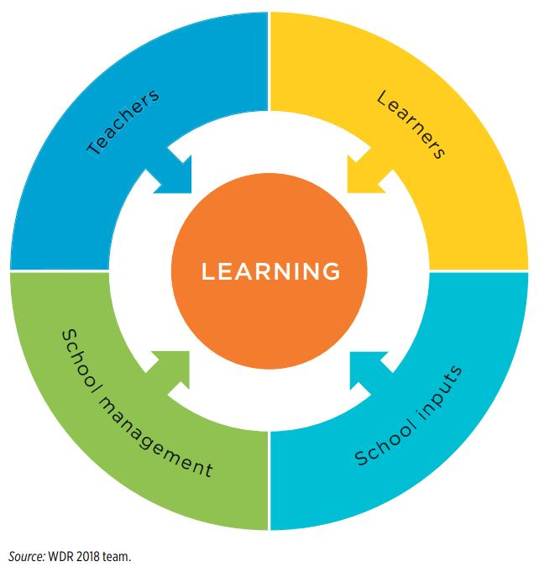
Children are not arriving to the class room ready to learn. The lack of foundation skills acquired in early childhood has a significant impact on learning outcomes. With chronic malnutrition, illness, lack of parental support and unpredictable situations associated with poverty, poor children lag behind their more affluent peers with gaps widening as children age. This is alarming because cognitive and language abilities are important predictors of performance throughout school and early adulthood. In addition to decreased cognitive skills, poor children also tend to have a lack of socio-emotional development (e.g., ability to control aggressive behavior, avoid distractions and get along with peers). Learning gaps appear to be caused by gaps in cognitive and socio-emotional abilities, and as these children grow older it becomes harder to break out of lower learning trajectories.

Teachers often lack the needed skills and motivation. According to work by Eric Hanushek, Barbara Bruns and Javiar Luque, teachers are the most important determinant of student learning. Yet, high quality teachers are in short supply in the developing world. Compounding this problem is the loss of teaching time due to absenteeism and less time on task when in class. When informal school closures and student absenteeism are taken into account, many countries see a marked decrease in instructional time. For example, only about 1/3 of the instructional time is used in Ethiopia, Ghana and Guatemala. Middle-income countries in Latin America lose about 20 percent of instructional time or the equivalent of one lost day per week for schooling. In addition to lost time for teaching, teacher absences represent major losses of resources for the education sector given that approximately 80 percent or more of the national education budgets in the developing world is dedicated to teacher salaries. The report cites a study in India in which 1,300 villages were assessed and found that 24% of teachers were absent during unannounced visits which was the equivalent of a $1.5 billion loss to the national education budget. Whether teachers lack skills or motivation or both, there is a heavy price paid when teachers are not properly trained, present and supported to teach children.

School management skills are low and school inputs have not kept pace. Management quality and school leadership are associated with better education outcomes, yet in many developing countries, school management is deficient as measured by management scores in education. At the same time, the expansion of primary education is doubling or tripling class size and limiting the effectiveness of instruction. Growing enrollment has clearly contributed to a decrease in per capita spending per student. For example, in Malawi between 2008 to 2015, as the gross enrollment rate increased from 131 to 146 percent, the average number of students per class increased from 85 to 126. While the introduction of universal primary education in Uganda increased enrollment by 68% there was a significant increase in the number of students per teacher (the student teacher ratio went from 38:1 to 80:1) and students per class (student-to-class ratio went from 68:1 to 105:1). These types of increases in enrollment without major increases in funding for education can impact the overall quality of education. An effective measuring system is needed to assess learning skills, identify problem areas, and guide policy decisions and investments required to address constraints on more effective learning.

Evidence & Recommendations – We need to understand that skills are multi-dimensional and that learning involves addressing different areas aimed at eventually creating a skilled, competitive workforce. In assessing what works, the report points to the large number of studies (e.g., 299 in 2016) which provide evidence on how to improve education outcomes. The problem is in trying to generalize individual studies that can have different results based on where and at what cost they are implemented. The report recommends a nuanced synthesis of studies in several areas with a focus on human behavior theory: (1) preparing students for school; (2) preparing and motivating teachers to teach; and (3) strengthening teacher-student interaction; and (4) building on foundations of learning by linking skills training to jobs. In addressing these areas, the focus should be on “gaps” – places where evidence of successful interventions is strong but where resources are not being invested by stakeholders. For example, early child investment shows great promise but is area lacking in investments by most governments and families. Certain types of teacher professional development approaches result in higher learning gains but are not adopted. Intuition and common sense are not enough, evidence is needed on impact and on the cost benefit of interventions in the context of where the approach will be used.

Preparing Students – The evidence clearly shows that investing in a child’s early years has a dramatic impact on later learning trajectories. A synthesis of the evidence indicates three key principles for improved learning: (1) early childhood nutrition, stimulation and learning opportunities can set a child on high-development trajectories and foster greater cognitive and socio-emotional development; (2 lower costs increase school attendance while motivational tools can increase learning outcomes; and (3) remedial education can result in greater learning and should be a available for those that need it. Skill development should be the ultimate goal of the education process with a focus on linking those skills to jobs. For more information, see pp. 112 – 130.

Preparing Teachers – Effective teachers are a critical part of the solution to the learning crisis. Although teacher salaries make up the bulk of education costs in developing countries there is a lack of emphasis on professional teacher development. To be effective, teacher training needs to be individually targeted with follow up coaching and an emphasis on teaching to the students’ level. Motivation and incentivizing teachers to increase their skills and teach effectively is important. Actions required of teachers must be within their capabilities and should focus on addressing issues that impede learning. Models of human behavior that can guide actions to improve teaching are effective and should be used. Various countries have established programs that improve learning outcomes through teacher professional development and provision of incentives. Specific recommendations are provided on pp. 131 – 144.

Strengthening Teacher-Student Interaction – Learners and teachers have a more productive learning relationship when supported by learning materials and other inputs. Technology can be important but it must complement teachers skills and must be able to be implemented in the local system. School governance is a critical input that along with community monitoring can improve learning. School management and governance are crucial and can help overcome incentive problems and information failures but only if communities have the willingness and capacity to get involved. However, a lack of capacity can cause problems -- data on one million students from 42 countries suggest that school autonomy is beneficial to student learning in high income countries but detrimental in developing countries. See pp. 132 – 153.

Linking Skills Training to Jobs – Many youth in the developing countries drop out of formal education prematurely and lack the foundational skills to be successful in the national labor market. The learning crisis is essentially transferred from schools to the workplace. Training can help – a cross country analysis of 38 workplace training studies found improved skills and an average wage increase of 7.2% for workers under 35 – but the literature indicates that few youth benefit from workforce training. Informal apprenticeships offer young people a way to upgrade their skills but require up-to-date master trainers and recognition of apprentice training through some type of certification in order to increase impact and provide workers with labor market mobility. Short-term job training programs offer opportunities but by and large do not meet labor market needs. Meta-analyses of these programs finds that less than a third have positive, significant impacts on employment and earnings. Successful short-term job training programs focus on multiple skill development and provide career guidance, mentoring and job search assistance. For example, in Brazil the Galpao Aplauso program focus on vocational, academic and life skills training in a comprehensive approach has produced good outcomes.
In terms of Technical and Vocational Education and Training (TVET), there have been positive results with workers in Brazil with upper secondary TVET workers earning wages 10% higher than workers with just a general secondary education. The potential problem with TVET is the risk of putting youth on a technical track too early. Evidence from advanced economies is that a narrow technical education conveys early advantages in the labor market but the advantages dissipate over time.

Successful job training programs should include the following aspects:

- Partnerships are established before training begins. Sectoral programs focused on careers rather than one off job placement have been shown to (i) improve labor market outcomes, (ii) raise productivity, and (iii) reduce employee turnover. High quality intermediaries and network aggregators are required to partner with companies in a specific sector to facilitate skills training and job placement. Three US sectoral training programs were cited as successful models of this approach.

- Capable teachers are identified and compensated. The global shift toward competency-based standards in training, assessment and certification amplifies the importance of capable, involved teachers. They need to be identified and sufficiently compensated.

- Combine classroom with workplace training. Studies show positive results for both firms and individuals that complete formal apprenticeships. In the US, a study of secondary TVET, post-secondary TVET and apprenticeship programs in Virginia and Washington state found positive gains in all three types of training with apprenticeships showing the most impact.

- Provide Career information and Guidance. Career guidance is an important part of training programs in helping students identify opportunities, stay on track in their training and skills acquisition, and in obtaining employment.

Successful job training programs are typically based on strong ties with employers and with instructors who have industry experience and are using up-to-date pedagogical methods. These programs tend to reinforce foundational skills, integrate classroom instruction with workplace learning, and offer training certification. A key lesson learned is that no matter the type of job training provided, trainees still need strong foundational skills – cognitive and socioemotional – before moving into specialized training.

Making the System Work at Scale – Different actors in the overall education system can have an impact on the basic elements of the system that misalign its overall focus on learning. Politic considerations, corruption and technical constraints can come together to trap a country in a low-learning, low accountability and high inequality equilibrium that is difficult to change.

The report suggests taking a systems approach to education with a focus on identifying issues and highlighting areas for corrective action. Incentives in the system must be aligned with learning, strategies for improving the system must be coherent, and information sharing is essential for system stakeholders to understand constraints and actions required to address them.

Three characteristics of complex education systems make reform difficult: (1) national education systems tend to be opaque – goals are hard to identify across different sectors and among different actors –
interactions are not apparent or understood; (2) bureaucratic inertia makes it difficult to improve learning or launch reforms; and (3) many of the actions required to successfully reform the system are beyond the capacity of the national education bureaucracy.

Politics can drive misalignments when vested interests of stakeholders divert systems away from learning in terms of designing, implementing, evaluating, and sustaining reforms. This can result in an education system stuck in a low-learning trap. Various actors – teacher unions, politicians, bureaucrats, the judiciary and private players – have to come together in ways that mitigate negative impacts on learning. Rent seeking has been identified as a major issue in diversion of resources from education with examples of problems occurring in the US, Mexico and India. The number of teachers in a country and their mobilization as a political force have an impact of the national political environment and teacher unions play a role in protecting their members sometimes at the expense of learning outcomes. The quantitative literature identifies situations in which unions may have undermined high-quality teaching and learning.

Escaping low-learning traps requires strong efforts in three areas (1) investing in improved information and acting on that information, (2) mobilizing coalitions of public, private and civil society stakeholders to support education and provide incentives for better learning outcomes, an (3) adopting a more iterative, adaptive approach to change.
“To innovate effectively—as indeed to build coalitions and use information for reform—education systems need strong, competent leadership. Research highlights three key attributes of effective leaders. First, they can clearly articulate problems and present clear visions for how to tackle them. Second, they mobilize human and financial resources around agreed-on goals and build coalitions to advocate for change and support implementation. Finally, effective leaders focus on identifying solutions that fit the institutional context.” P. 211

Adrian Leftwich,. 2009. “Bringing Agency Back In: Politics and Human Agency in Building Institutions and States, Synthesis and Overview Report.” DLP Research Paper 6, Developmental Leadership Program, Birmingham, U.K

Increased information flows can increase political pressure for change, mobilize local stakeholders to take action and provide incentives to schools to have better learning outcomes. The lack of appropriate information systems is a major constraint. For example, an assessment of the capacity to monitor progress toward education outcomes in 121 countries found that a third lacked data on learning outcomes at the end of primary school and half had insufficient information on learning at the end of secondary school.

In filling the information void, there are some interesting examples of citizen-led assessments in South Asia and Sub-Saharan Africa where civil society organizations led actions to test children in and out of school for basic reading and mathematics competencies and were able to disseminate the findings to raise awareness to the learning crisis. This helped mobilize support and build coalitions which is critical to promoting actions required to improve learning outcomes. Building partnerships between schools and communities is critical as well and has proven successful especially in fragile or conflict prone areas. Coalitions help increase political will (dependent on public awareness and response) to align system actors with learning. Examples from Chile, India, Indonesia and Tanzania demonstrate how different stakeholders were brought together to identify constraints, design actions to address them, and then mobilize a national coalition to address them.

A key part of this process is seeking local solutions that are based on adapting good policies and programs to local conditions. An example of Burundi’s ability to improve education services after a protracted civil war. Peru provided a good example of incorporating information systems into effective change with its MineduLAB program in which innovations are introduced directly into government schools based on timely performance information. Education systems also need to be agile to exploit critical moments when trade opportunities or investment initiatives signal a need for broad-based training. Leadership is critical and is needed to promote effective innovation.

What can the donor community do?

External actors can support initiatives to improve learning by (1) helping create objective, politically salient information, (2) encouraging flexibility and support for reform coalitions, and (3) linking financing more closely to results that lead to learning

MAKING THE SYSTEM WORK AT SCALE

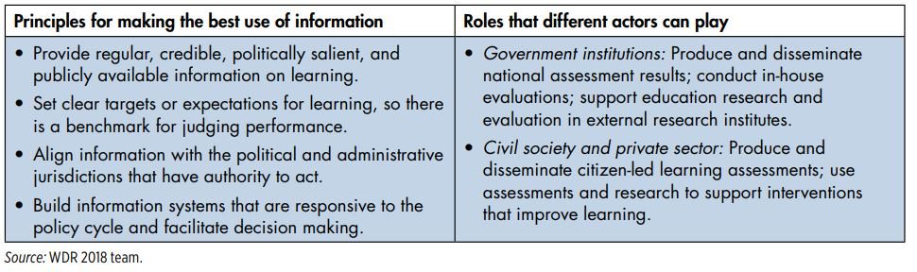
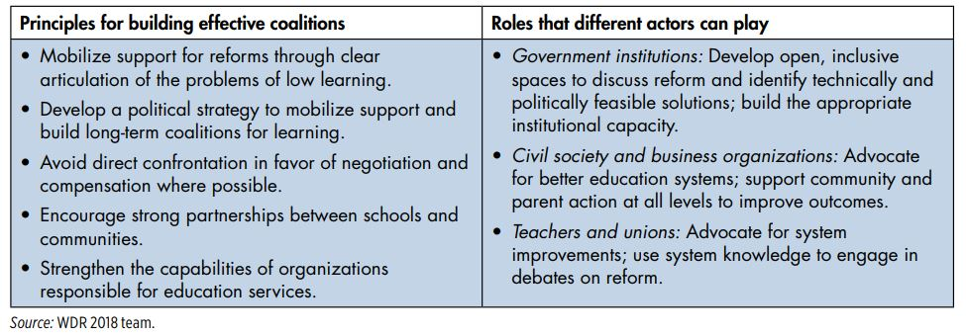
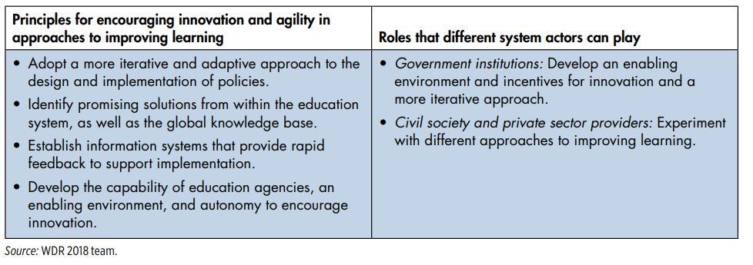

Attribution: World Bank. 2018. World Development Report 2018. Learning to Realize Education’s Promise. Washington DC: World Bank. Doi:10.1596/978-1-4648-1096-1. License: Creative Commons Attribution CC by 3.0 IGO.
The report highlights the success in creating greater access to education with the years of schooling completed by the average adult in the developing world more than tripling between 1950 and 2010 (going from 2 years to 7.2 years). But this achievement is offset by tremendous shortfalls in basic literacy in reading, writing and math as reported by UNESCO where on a global level -- and acquire significantly less learning than children from higher income households – poor children learn the least which hurts them the most. At a national level, the failure to learn affects long-term social and economic development.
From the Report - Part One – Schooling, Learning and the Promise of Education, pp. 38 – 54.
From the Report - Spotlight 1 - “The Biology of Learning” – pp . 68 – 70 – “The available insights on brain development have implications for investments in learning and skill formation. Because brain malleability is much greater earlier in life and brain development is sequential and cumulative, establishing sound foundations can lead to a virtuous circle of skill acquisition.”
From the report – pp. 3-4 - “Any country can do better if it acts as though learning really matters.” – Vietnam in 2012 had its 15 year olds scoring at the same level as German youth on scores under the Program for International Student Assessment (PISA) tests.
Hanushek, Eric A., Guido Schwerdt, Simon Wiederhold, and Ludger Woessmann. 2015. “Returns to Skills around the World: Evidence from PIAAC.” European Economic Review 73: 103–30.
Hanushek, Erica A. 1979. “Conceptual and Empirical Issues in the Estimation of Educational Production Functions.” Journal of Human Resources 14 (3): 351-388. ------. 1992. “The Trade-Off between Child Quantity and Quality.” Journal of Political Economy 100 (1): 84-117.
Bruns, Barbara, and Javiar Luque. 2015. “Great Teachers: How to Raise Student Learning in Latin America and the Caribbean. Latin American Development Forum Series. Washington DC: World Bank
Bloom, Nicholas, Renata Lemos, Raffaella Sadun, and John Van Reenen. 2015. “Does Management Matter in Schools?” Economic Journal 125 (584): 647–74.
Multidimensionality of Skills – The report cites on pp 102 to 104 that there are three broad skill categories (1) cognitive skills which include the ability to understand complex ideas, engage in various forms of reasoning, learning and professional development, (2) socioemotional skills which are needed to deal at an interpersonal and social level effectively (e.g., self-awareness, leadership, teamwork, self-control), and (3) technical skills which are the acquired knowledge, experience and interactions needed for competent performance of duties. The basic foundations of cognitive skills include basic literacy, numeracy, critical thinking and problem-solving are best learned at an early age. Higher order cognitive skills and adaptive learning are built on this foundation.
Hanushek, Eric A., Susanne Link, and Ludger Woessmann. 2013. “Does School Autonomy Make Sense Everywhere? Panel Estimates from PISA.” Journal of Development Economics 104: 212–32.
Kluve, Jochen, Olga Susana Puerto, David A. Robalino, Jose Manuel Romero, Friederike Rother, Jonathan Stöterau, Felix Weidenkaff, et al. 2016. “Do Youth Employment Programs Improve Labor Market Outcomes? A Systematic Review.” IZA Discussion Paper 10263, Institute for the Study of Labor, Bonn, Germany.
Calero, Carla, Carlos Henrique Corseuil, Veronica Gonzales, Jochen Kluve, and Yuri Soares. 2014. “Can Arts-Based Interventions Enhance Labor Market Outcomes among Youth? Evidence from a Randomized Trial in Rio de Janeiro.” IZA Discussion Paper 8210, Institute for the Study of Labor, Bonn, Germany.
Wisconsin Regional Training Partnership (Milwaukee), Jewish Vocational Service (Boston), Per Scholas (New York City)—participants saw 18 percent higher average earnings over a two-year period.44 Similarly, the Year Up program, which targets vulnerable youth in several U.S. states, has produced high levels of completion, participation in internships, employment, and earnings
P. 172 - A systems approach takes into account the interactions between the parts of an education system. In doing so, it seeks to understand how they work together to drive system outcomes, instead of focusing on specific elements in isolation. It can help assess whether different actors and subsystems align with education goals and shed light on the underlying drivers of system performance.”
P. 172 – “An education system is a collection of “institutions, actions and processes that affect the ‘educational status’ of citizens in the short and long run. Education systems are made up of a large number of actors (teachers, parents, politicians, bureaucrats, civil society organizations) interacting with each other in different institutions (schools, ministry departments) for different reasons (developing curriculums, monitoring school performance, managing teachers). All these interactions are governed by rules, beliefs, and behavioral norms that affect how actors react and adapt to changes in the system.”

