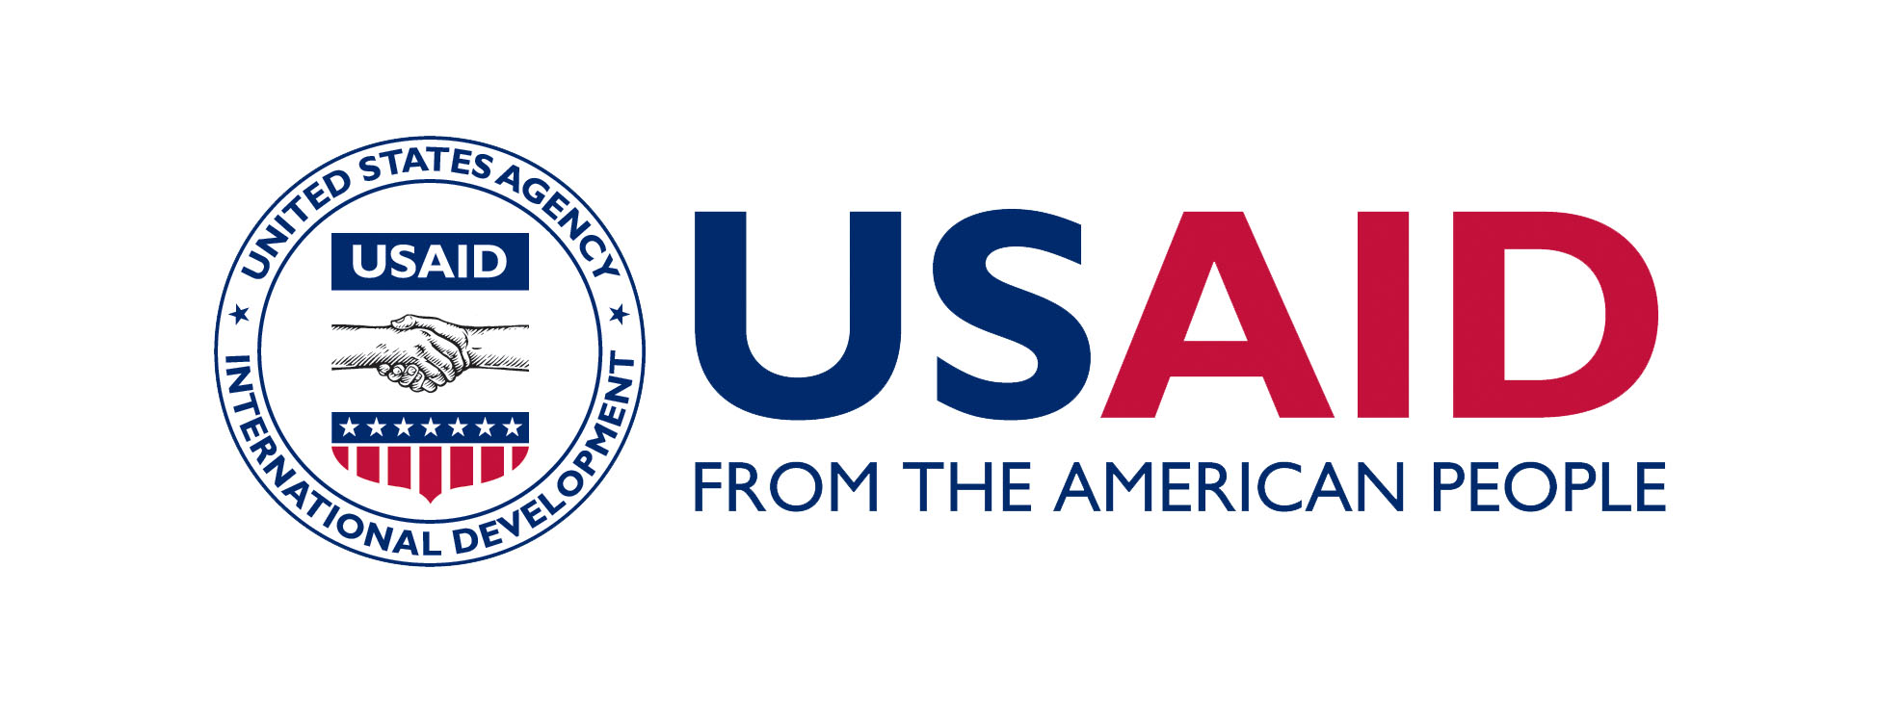
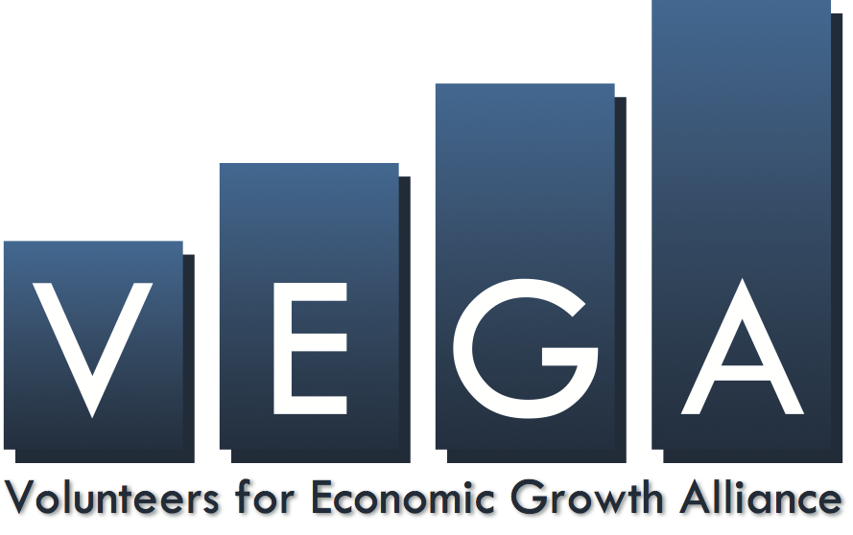

BRANDING STRATEGY AND MARKING PLAN

Project Title: Competitive Agriculture Systems for High Value Crops (CASH)
RFA No.: RFA-279-14-000001
Period of Activity: April 15, 2014 – April 14, 2019
Implementing Organization: Land O'Lakes International Development

Overview: Robust communications are essential to ensuring the success of this $24.5 million, five-year Volunteers for Economic Growth Alliance (VEGA) program, whose goal is to create sustainable market systems that increase rural incomes and enable poor Yemenis to purchase the food necessary to ensure proper household nutrition and improved food security. More specifically, the program will look to develop high value horticultural chains that can compete with the drug qat, which currently consumes half of the country’s dwindling water supply. Implemented by Land O’Lakes International Development through VEGA – in partnership with the International Executive Service Corps (IESC), the Coffee Quality Institute (CQI) and Aid to Artisans – CASH will help cultivate sustainable markets for Yemeni coffee, honey, horticulture, livestock and handicrafts, with the intention of making efforts commercially profitable and scalable. CASH and its complementary outreach efforts have been structured according to three phases, and several corresponding components:

- Phase 1, Project Analytics: Lasting only three months, this initial phase will focus on engaging in a number of crucial analyses designed to facilitate accelerated implementation in years 2-5, including analyses focused on end markets, access to finance, the costs and benefits of investment, the environment and market resources, conflict triggers, in addition to a Baseline Study of Household Nutritional Impacts, Income and Household Dynamics.
- Phase 2, Proof of Concept Pilot Activities: Following the completion of these analyses, Land O’Lakes and USAID will launch pilot projects focused on high value horticulture, honey, livestock and handicrafts, and will evaluate the extent to which they improve productivity, expand markets and trade, increase agricultural investments, and increase employment.
- Phase 3, Commercialize and Scale Select Value Chains: Finally, from years two through five, the goal will be on bringing successful pilot efforts to scale and ensuring profitability, through the lens of components focused on the development of market access, value chains and agricultural credit.

Each component of CASH will incorporate outreach efforts that support program deliverables, enhance knowledge management, and help create feedback loops facilitating the timely augmentation of programmatic approaches and activities when needed. This Branding Strategy and Marking Plan provides illustrative examples of the approaches Land O'Lakes will take in its communications strategy as the implementing organization, with more detailed information to be included in the forthcoming work plan.

Land O’Lakes and its partners will make every effort to clearly and consistently convey USAID’s vitally important role on signage and through print materials. At the same time, Yemen’s precarious security situation may require that certain sites and activities not be branded, either temporarily or permanently. Land O’Lakes will also make every effort to ensure that the VEGA brand is also enhanced through the program, and contains messages that buttress the benefits of working through this LwA mechanism. References to Land O’Lakes will generally be subordinate, and will just clarify that it is the implementer of CASH activities. The determination of whether security considerations need to temporarily or permanently trump branding decisions will be made collaboratively with USAID. In such cases where it has been collaboratively deemed unsafe to display the USAID or VEGA logos, Land O’Lakes will display the Republic of Yemen logo.
USAID Branding Strategy

Positioning: In all public communications including events, speeches, press releases, Requests for Applications (RFAs), Annual Program Statements (APS) and published materials), the project will be referred to as the Competitive Agriculture Systems for High Value Crops in the first instance, and generally by its acronym CASH, thereafter.

- Land O’Lakes will always use the VEGA logo below, unless VEGA develops a program-specific VEGA/CASH logo.

Land O’Lakes will take every opportunity to provide maximum exposure to both USAID and VEGA through the CASH program in Yemen. In addition to placing a description of the VEGA alliance on the www.idd.landolakes.com website, we will also provide a link to the www.vegaalliance.org website on all public outreach materials about the program. In all cases, the program will also bear the USAID logo, in equal or greater prominence than the VEGA logo, unless security considerations make the placements of all logos unwise. The USAID logo will always appear on the left and the VEGA logo will appear on the right, as shown below:
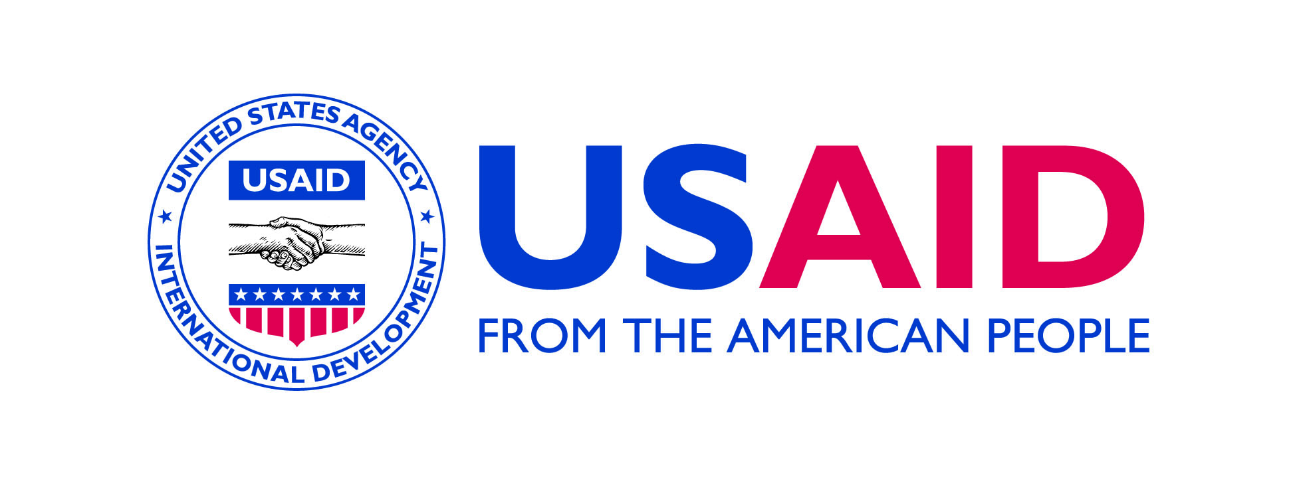

Land O’Lakes understands that the use of its own logo will generally be limited to a subordinate placement on internal technical and program reports. For technical and program reports, the USAID/VEGA cobranding will appear at the top of the document, with the reference to Land O’Lakes at the bottom of the cover page, as shown below:


Implemented by

Land O’Lakes will not use its own logo in promotional materials produced with program funds. The Land O’Lakes logo will, however, be included in a subordinate role on headquarters-produced outreach materials (e.g. country fact sheets, newsletters) that are produced using General and Administrative (G&A) funds. When tailoring these pieces to suit the needs of Land O’Lakes outreach efforts, it will be made clear that Land O’Lakes is the implementing organization, but that this program has been awarded to VEGA. Regardless of whether CASH materials are produced with program or G&A funds, in the field or at the HQ level, all materials will be sent to VEGA and USAID in advance for review, since they will all reference VEGA and USAID.

In any cases where USAID, VEGA and Land O’Lakes have collaboratively determined it is unsafe to place the typical branding described above, the program will brand project sites with the Republic of Yemen Government (ROYG) logo:



In addition to logo placement, USAID will be identified as the sponsor of CASH including through the use of one of the following combinations of tag lines:

  - “(made possible) with the generous support of the American People” for public communications such as banners, signs and communication at public events, conferences and in media, or

  - “From the American People” for program deliverables, reports and studies etc.

- Audience: In order to fully promote effective development strategies that translate into meaningful and lasting agricultural opportunities in Yemen, we intend to engage a diverse audience through program communications, including:

  - Communities at large in the CASH areas of operation
  - Local business and community leaders
  - Chambers of Commerce and business association
  - Vulnerable populations, including women
  - Private sector partners both inside and outside of Yemen
  - Local policymakers and government officials
  - U.S. media, international donors and agencies (secondary)
  - Other implementing partners in Yemen (secondary)

- Main Program Message: While the program’s messages will be customized to some extent depending on the audience and the specific communication tools and tactics employed, the general message is as follows: The American People, through USAID, are helping to create sustainable market systems, increase rural incomes, and improve nutrition and food security for the people of Yemen through the CASH program.

- Communications and Program Materials: As described in the overview of this branding strategy and marking plan, communications will be integrated throughout CASH and generated by all program components. While greater specificity will be provided about the communications tools and tactics in the forthcoming detailed work plan, some illustrative examples of program materials that will be created, branded and marked are as follows:

- Phase 1: The outputs of all analyses created through Phase 1 – end markets, access to finance, the costs and benefits of investment, the environment and market resources, conflict triggers, in addition to a Baseline Study of Household Nutritional Impacts, Income and Household Dynamics – will all be clearly branded to highlight the support of USAID and the American people. USAID’s role will also be verbally communicated when and if the background research for these analyses requires in-person interviews with specific informants and institutions.

- Phase 2: During this phase, we will launch pilot projects focused on high value horticulture, honey, livestock and handicrafts, and will evaluate the extent to which they improve productivity, expand markets and trade, increase agricultural investments, and increase employment. All of these pilot activities will be co-branded with USAID and VEGA logos to the extent appropriate for each pilot, unless there is a collaborative decision that security considerations warrant that these sites be branded with the ROYG logo instead. All relevant reports highlighting the findings from these pilot projects will also be clearly co-branded with USAID and VEGA logos. To the extent that pilot activities in the selected value chains include participation in public expos or promotional activities, these efforts will also be appropriately branded with the USAID logo. Similarly, corollary demonstrations of improved agricultural technologies and water irrigation systems, will also be co-branded with the USAID and VEGA identities, provided there is a consensus that this will not present any security concerns. When appropriate, banners highlighting the USAID and VEGA co-branding will also be placed prominently within venues used for training farmers and/or artisans.

  - Phase 3: Finally, from years two through five, the goal will be on bringing successful pilot efforts to scale and ensuring profitability, through the lens of components focused on the development of market access, value chains and agricultural credit.

    - Component 1: Market Access and Development. To the extent possible, based on the types of venues used to host the sector-specific Cluster Working Groups, we will hang banners with the USAID logo making clear the American people’s support for this important initiative. More importantly, we envision significant branding and marking opportunities will arise through Activity 1.2, focused on export promotion activities. Participants’ booths at public expositions and related marketing materials will all give appropriate recognition to USAID, while information about the program will be woven, to the extent possible, into descriptions of roundtable events and other outreach events. If the CASH work plan moves forward with current plans to develop a radio program that provides stakeholders with relevant market information, this two will feature a verbal credit noting that the program was made possible by the American people through USAID. The AgPro tool, already developed by Land O’Lakes through support from USAID, will remain with its current co-branding of USAID and Land O’Lakes International Development logos.

    - Component 2: Value Chain Development. As part of our efforts to accelerate innovation in the programs focus value chains, we will clearly highlight USAID’s critical support in Innovation Solicitations, and at related innovation events, trade shows and TEDx forums. Our outreach through these forums will also be buttressed by robust promotion through social media channels, and efforts to raise awareness about innovations through stories in the domestic and international media, blogs, and existing communications tools used by USAID, Land O'Lakes and our partner organizations. When and if CASH financial resources are brought to bear to realize needed infrastructure improvements through Activity 2.5, we will ensure a plaque is placed outside the venue (security constraints permitting) that will acknowledge that the support for such construction was made possible by USAID. Any printed training materials used to integrate vulnerable households into CASH’s key value chains will also be appropriately co-branded with the USAID logo. When and if nutritional messages are placed on billboards and other mass media forums, we will ensure that USAID and the American people receive recognition for such support.

    - Component 3: Agricultural Credit Development. When approaching potential commercial lenders, IESC will be sure to speak to how the program has been made possible by USAID, and the potential for securing guarantees through USAID’s DCA program. Once created, the public materials highlighting the new financial tool will also be branded to reflect USAID support, and Land O’Lakes will seek to conduct media outreach highlighting the success stories and other impacts from this expanded financial support for select Yemeni value chains Training sessions provided by CASH to select microfinance institutions, banks and investors will also bear signage that highlight USAID support, while the training materials used will also be branded.

  - Other: In addition, Land O’Lakes will be responsible for producing a fact sheet about the program in electronic and hardcopy versions, and writing quarterly success stories that will be posted on its website, as well as on VEGA’s and USAID’s. Other publications will be considered as the work plan is further fleshed out, to potentially include longer program brochures and/or reports. As discussed above, all outreach materials produced using program funds will be clearly co-branded with VEGA and USAID logos, unless a mutual decision between USAID and CASH implementers regarding security concerns precludes such branding. As noted earlier, Land O’Lakes International Development may produce materials using G&A funds that also use the Land O’Lakes International Development logo, in cases where the template for that specific communication vehicle (e.g. website) cannot be changed.

USAID Marking Plan

- Overview: In general, any studies, reports, papers, publications, audio-visual productions, public service announcements, Web sites/Internet activities and other promotional, informational, media, or communications products funded by USAID will be marked with the USAID Identity and will comply with 22 CFR 226.91.

- Marking of sub-awards: We will also work to ensure that all sub-awardees fully comply with USAID marking requirements, and will include the following language in any sub-awards:

As a condition of the recipient of the sub-award, marking with the USAID Identity of a size of prominence equivalent to or greater than the recipient’s, sub-recipient’s, other donor’s, or third party is required. In event the recipient chooses not to require marking with its own identity or log with the sub-recipient, USAID may, at its discretion, require marking by the sub-recipient with the USAID Identity.

This sub-award language will make clear that the recipient logo it must include is the VEGA logo, not the Land O’Lakes International Development logo.

- Disclaimer language for publications: All studies, reports, publications, web sites, and all informational and promotional products will contain the following provision:

This study/report/Web site (specify) is made possible by the support of the American people through the United States Agency for International Development (USAID). The contents are the sole responsibility of the (name of organization) and do not necessarily reflect the views of USAID or the United States Government.

We will also secure translations of the appropriate disclaimer language in Arabic, when materials are published in a language other than English.

Name of submitting organization: | Volunteers for Economic Growth Alliance (VEGA), through implementing partner, Land O’Lakes International Development.
Name of project: | Competitive Agriculture Systems for High Value Crops (CASH)
USAID reference number, if any:  (cooperative/grant agreement number if awarded or RFP/RFA number if not-as-yet awarded) | RFA-279-14-000001
Check one in the next column: | awarded cooperative agreement  __ awarded grant  __ unsolicited proposal  _X_ solicited proposal (RFA/RFP)
Submitted to:
Date Marking Plan submitted: | January 13, 2014
Estimate of costs associated with marking this program:
Sub-recipient Marking Plans | Not Applicable

- Description of the public communications, commodities, and program materials that CASH will produce as a part of the project and which will visibly bear the USAID Identity (USAID logo or seal and new brandmark, with tagline reading “From the American people” – available at www.usaid.gov/branding).

- Program, project, or activity sites funded by USAID, including visible infrastructure projects (for example, roads, bridges, buildings) or other programs, projects, or activities that are physical in nature (for example, agriculture, forestry, water management).

As described in detail in the description above, Phase 2 of the program will help to pilot projects focused on high value horticulture, honey, livestock and handicrafts, which will be co-branded with USAID and VEGA logos to the extent appropriate for each pilot, unless there is a collaborative decision that security considerations warrant that these sites be branded with the ROYG logo instead. In addition, any sites used to demonstrate technology innovations – such as improved irrigation methods – will also be appropriately branded.

- Technical assistance, studies, reports, papers, publications, audio-visual productions, public service announcements, websites/Internet activities and other promotional, informational, media, or communications products funded by USAID.

All CASH implementers will ensure that its programs, projects, activities, public communications, and commodities will be marked appropriately overseas with the USAID Identity of a size and prominence equivalent to or greater than the one for VEGA or any other donor’s or third party’s identity or logo (including the Land O’Lakes logo, when allowable). The only exceptions to USAID branding will arise when there is a mutual agreement between USAID and CASH implementers that security constraints make it unwise to publically brand the program. In such cases, if appropriate, they will instead be branded with the ROYG logo. Brochures, reports, studies and other public communications, as defined in 22 C.F.R. 226.2, funded by USAID, in which the content has not been approved by USAID, will contain the following disclaimer:

“The study/report/audio/visual/other information/media product (specify) is made possible by the generous support of the American people through the United States Agency for International Development (USAID). The contents are the responsibility of VEGA and do not necessarily reflect the views of USAID or the United States Government.”

- Events financed by USAID such as training courses, conferences, seminars, exhibitions, fairs, workshops, press conferences, and other public activities (for example, displaying signs and banners with the USAID Identity, or if the USAID Identity cannot be displayed visually, acknowledging USAID and the American people’s support through the spoken word).

As described in great detail above, we envision a number of opportunities in Phases 2 and 3 for the CASH team to strengthen key value chains and trade by participating in expos, conferences, roundtables, training sessions and other events. Participants’ booths and collateral materials will include some level of USAID branding (without usurping their own identities), as will any training materials provided to participants. The CASH team will ensure that all training courses, seminars, workshops and PowerPoint presentations will be marked appropriately overseas with the USAID identity of a size and prominence equivalent to or greater than VEGA’s, Land O'Lakes’ or any other donor’s or third party’s identity or logo. In cases when USAID Identity cannot be displayed visually, CASH staff members will ensure acknowledgement of USAID and the American people’s support through the spoken word.

CASH staff will also ensure that they coordinate and seek USAID approval for all to press releases, fact sheets and similar promotional materials when organizing events or other public activities, and will use “notes to the editors” as recommended by the specific mission or bureau or both.

- All commodities financed by USAID, including commodities or equipment (but excluding CASH offices, vehicles, and non-deliverable items for internal use in administration) provided under humanitarian assistance or disaster relief programs, and all other equipment, supplies and other materials funded by USAID and their export packaging.

Not applicable, unless specific equipment is purchased by CASH through Activity 2.5 to effect needed physical market infrastructure for specific value chains. This will be determined alongside the development the detailed work plan, as the program progresses.

- Table of program deliverables that WILL be marked with the USAID Identity by Land O’Lakes and any sub-recipients.
Included in the table below are (a) the program deliverables that CASH and any sub-recipients will mark with the USAID Identity, (b) the type of marking (for example, plaque or adhesive labels) and what materials will be used to mark the program deliverables with the USAID Identity, (c) when in the performance period the program deliverables will be marked, and (d) where the marking will be placed.

Description of Deliverable | Type of Marking and  What Materials | When Marked | Where USAID Identity Placed
Reports, studies | USAID Identity of a size and prominence equivalent to or greater than VEGA or any other donor or third party’s identity or logo and with a prescribed disclaimer | When printed | On top left corner of cover page, and on bottom left corner of back page. VEGA on the top right corner of cover page and on the bottom right corner of back page. Land O’Lakes logo will appear in a subordinate size at the bottom center of the cover page, with words indicating it is the implementing organization.
Public page(s) of program funded website  (Not expected to be applicable.) | Land O’Lakes will ensure that the main program page of content on the www.idd.landolakes.com website includes co-branded USAID and VEGA logos. Land O’Lakes logo will still remain prominent, as it is incorporated into the site’s overall template and cannot be changed. | When created and made viewable to the public. | We do not expect to develop a discrete CASH website funded through the program. Land O’Lakes will create a page for the CASH program on its existing www.idd.landolakes.com website, which was produced through G&A funds. As such, the site is not co-branded with USAID’s logo.
PowerPoint presentations | USAID Identity of a size and prominence equivalent to or greater than VEGA or any other donor or third party’s identity or logo and with a prescribed disclaimer | When created | On top left corner with VEGA logo placed on the top right corner
Program Reports | USAID Identity of a size and prominence equivalent to or greater than VEGA) or any other donor’s or third party’s identity or logo and with a prescribed disclaimer | When printed | On bottom left corner of cover page, and on bottom left corner of back page. VEGA logo on the bottom right corner of cover page and on the bottom right corner of back page. Land O’Lakes logo will appear in subordinate size at the bottom center of the cover page, indicating it is the implementing organization.
Seminars, courses and workshops | Banners and similar promotional tools that bear USAID Identity with equal or greater prominence alongside the VEGA logo. | At event | At the entrance or other highly visible locations at events, and on all signage.
Exposition booths and collateral materials for program beneficiaries | In this case, USAID marking will be subordinate to that of the program beneficiary, so as not to create confusion, but will include the USAID brand mark, alongside written language saying, “Funded by” |  | This will vary from partner to partner, based on the format of their existing marketing materials.

- Table of program deliverables that will NOT be marked with USAID Identity by Land O’Lakes and any sub-recipients.
Include in the table (a) what program deliverables will not be marked with the USAID Identity and (b) the rationale for not marking these program deliverables.

CASH requests a Presumptive Exception for the deliverables in the table below.

Description of Deliverable | Rationale for Not Marking
Potential Presumptive Exception  Government policies (Ministry of Agriculture’s), strategies, plans and guidelines or other materials positioned as being from the host-country government.  Specific government policies/strategies/plans this might pertain to will be fleshed out in forthcoming work plans. | While we do not expect to develop any specific policies, we are cognizant that CASH is intended buttress and facilitate the implementation of existing plans and policies of the ROYG, and its Social Development Fund. To the extent that we learn that a specific activity or set of efforts have already been publically positioned as being led by the ROYG, we will work with USAID to determine the most sensitive manner in which to publically present that activity and relevant branding, at a minimum ensuring that the ROYG logo appears alongside other branding.  As per 320.3.2.5, the rationale for this requested exception relates to the exemption for policies, strategies, plans, and guidelines under that rationale that (iii): USAID branding would undercut host-country government “ownership” of constitutions, laws, regulations, policies, studies, assessments, reports, publications, surveys or audits, public service announcements, or other communications better positioned as “by” or “from a cooperating country ministry or government official (22C.F.R.226.91(h) 3).
Potential Future Waiver  Branding of infrastructure and demonstration sites in Phases 2 and 3 | We are acutely aware of the precarious and often fluid security environment in Yemen, including Al-Qaeda and other terrorist groups, as well as actors involved with the qat industry who might take issue with alternative development efforts led by USAID. While it is currently our intention to fully co-brand each site with the USAID identify, we will need to work in partnership with the mission to ensure the safety and security of project staff and local partners remains the highest priority. To the extent that USAID, VEGA, Land O’Lakes or other local partners receive intelligence or threats about potential or similar attacks elsewhere, we will need to discuss with the mission how best to brand (or not) in light of security concerns. As the ultimate brand in question here is that of USAID, we will take the Principal Officer’s lead as to how to nimbly respond to shifts in the security environment, and will work in full compliance of ADS 320.3.2.6 as needed.

